**Software Requirements Specification**

**for**

Leveraging regional and digital data inferences to streamline business models

**Prepared by**

**Batch: A**

|  |  |  |
| --- | --- | --- |
| [**Pranati Bharadkar**](mailto:ppbharadkar@gmail.com) | **2020400002** | **pranati.bharadkar@spit.ac.in** |
| **Swamini Dumbre** | **2020400009** | **swamini.dumbre@spit.ac.in** |
|  |  |  |
|  |  |  |
|  |  |  |

|  |  |
| --- | --- |
| **Instructor:** | **Prof. Dr. Prasenjit Bhavathankar** |
|  |  |
| **Course:** | **Software Engineering** |
|  |  |
|  |  |
| **Date:** | **01/09/2022** |

**Contents**

**REVISIONS III**

**1** **INTRODUCTION 1**

1.1 Document Purpose 1

1.2 Product Scope 1

1.3 Intended Audience and Document Overview 1

1.4 Definitions, Acronyms and Abbreviations 1

1.5 Document Conventions 1

1.6 References and Acknowledgments 2

**2** **OVERALL DESCRIPTION 3**

2.1 Product Perspective 3

2.2 Product Functionality 3

2.3 Users and Characteristics 3

2.4 Operating Environment 3

2.5 Design and Implementation Constraints 4

2.6 User Documentation 4

2.7 Assumptions and Dependencies 4

**3** **SPECIFIC REQUIREMENTS 5**

3.1 External Interface Requirements 5

3.2 Functional Requirements 6

3.3 Behaviour Requirements 6

**4** **OTHER NON-FUNCTIONAL REQUIREMENTS 7**

4.1 Performance Requirements 7

4.2 Safety and Security Requirements 7

4.3 Software Quality Attributes 7

**5** **OTHER REQUIREMENTS 8**

**APPENDIX A – DATA DICTIONARY 9**

**APPENDIX B - GROUP LOG 10**

# Introduction

Modeling consumer data to customize regional services, optimize supply chain and increase customer satisfaction

## Document Purpose

To study how companies across various domains leverage data to streamline customer experience.

To propose an ideal implementation model to optimize consumer satisfaction, while saving cost, time and unnecessary inventory.

## Product Scope

*In the ecommerce industry logistics and supply chain are a big hussle and the player who optimises this will be the final winner. Our product aims to use consumer data to build a perfect ecosystem of warehouses using a combination of collection centres and micro and macro warehouses in cities to optimize the supply chain, thus reducing the inventory, labour, logistics cost.* We achieve this by firstly predicting what consumers in a region will buy and then storing those items near their city.

## Intended Audience and Document Overview

This document is meant for Product Operations and Engineers working on optimizing supply chains. We will provide a machine learning approach to cluster consumer segments and optimize the logistics behind products.

## References and Acknowledgments

*1.*[*https://sigir-ecom.github.io/ecom2018/ecom18Papers/paper8.pdf*](https://sigir-ecom.github.io/ecom2018/ecom18Papers/paper8.pdf)

*2.*[*https://www.kaggle.com/benroshan/ecommerce-data*](https://www.kaggle.com/benroshan/ecommerce-data)

*3.*[*https://tinuiti.com/blog/amazon/amazon-supply-chain/*](https://tinuiti.com/blog/amazon/amazon-supply-chain/)

*4.* [*https://www.helium10.com/blog/amazon-supply-chain-explained/*](https://www.helium10.com/blog/amazon-supply-chain-explained/)

# Overall Description

## Product Perspective

Any ecommerce business starts to order deliveries by postal service or on similar lines and after it starts growing it needs to set up warehouses to reduce delivery time. We help them find optimal solutions for this.

Our model is a new system that intends to replace the current methods in which inventory management is done, right from recommending the optimal set of products and pricing models to the right audience, as well as streamlining the supply chain management.

## Product Functionality

1. Ecommerce companies on boards to our platform.
2. Upload their consumer and product data containing date of purchase, shipment address, reviews of product, vendor address, margin for product etc.
3. We use this data to build a prediction/ recommendation system of when and what users will buy.
4. Identify specific demands of cities and states.
5. Build a warehouse ecosystem model to optimize the supply chain.

## Users and Characteristics

1. *Ecommerce giants ( non perishable goods) wanting to optimize warehouses.*
2. *Fresh Fruit delivery companies.*
3. *Thrift Stores.*
4. *Small Businesses operating pan-India.*
5. *Cold Storage Plants.*
6. *Companies whose raw materials come from different sources.*

*Figure 1.0 explains the basic flow of our proposed model.*

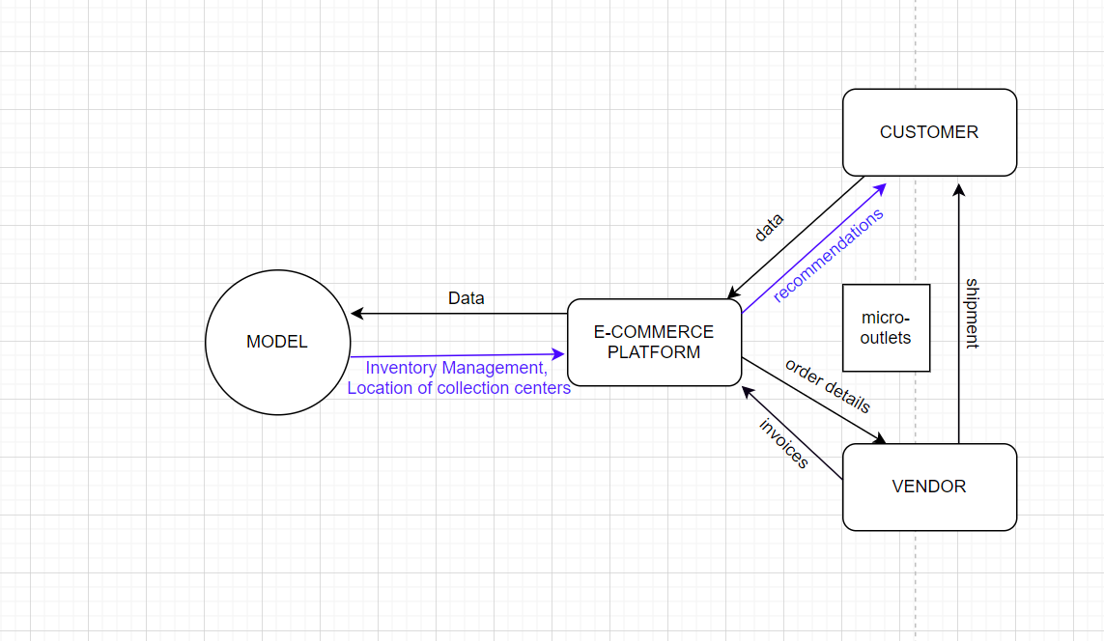

**Figure 1.0**

## Operating Environment

OE-1: This model will use a website running on React Frontend and Django as back-end with Postgresql.

OE-2: This model will use Machine Learning Algorithms like Regression, Clustering and Deep Learning using TensorFlow to build a prediction system.

OE-3: We use algorithms to build a perfect warehouse ecosystem according to the prediction model.

## Design and Implementation Constraints

CO-1: Companies might have only a limited amount of data, using which we may not be able to draw extremely concrete inferences.

CO-2: It may not be viable to use certain kinds of data for academic and test purposes.

CO-3: Authenticity and nature of data may not be assured, as a result of which it may be difficult to draw logical inferences and craft strategies.

## User Documentation

UD-1: Users will be given directions to use on the frontend using alerts, tosts, links, etc.

## Assumptions and Dependencies

AS-1: Companies might have only a limited amount of data, using which we may not be able to draw extremely concrete inferences.

AS-2: Companies have enough money to build the warehouse ecosystem.

DE-1: The operation of the COS depends on changes being made in the Payroll System to accept payment requests for meals ordered with the COS.

DE-2: The operation of the COS depends on changes being made in the Cafeteria Inventory System to update the availability of food items as COS orders are accepted.

# Specific Requirements

## On-boarding Companies (E-commerce players)

* + 1. We create a user model using Django to on-board ecommerce companies.
    2. Proper instruction will be provided to understand the working of the website.
  1. **Uploading their consumer data and vendor data.**
     1. We let companies upload their consumer data and we store it in postgre database.
     2. We would need the date of purchase, shipment address of the consumer.
     3. We need product reviews and vendors for a product.
     4. We need vendor address and product sub-category they are selling.
  2. **Building Prediction Model to help companies**
     1. We use a clustering algorithm for specific subcategories of products.
     2. Use regression to predict what and when a customer will buy.
     3. We provide this data to companies on their admin panel and they can use this to promote specific products to specific customers.
  3. **Building Warehouse Ecosystem with proper ranking to warehouse priority.**
     1. According to the predictions for users we suggest a model such that it has collection centers near vendors and macro warehouses near collection centres/ micro warehouses and macro warehouses near consumers and micro warehouses/ collection centres near consumers.
     2. We suggest this ecosystem to companies using the admin interface.

**4 External Interface Requirements**

## 4.1 User Interfaces

UI-1: The system shall provide a login page that enables a registered ecommerce platform to sign in, or a new platform to sign up and avail the services.

UI-2: The landing page consists of a link to upload the dataset of customers by the ecommerce company.

UI-3: It also contains a link to upload a dataset pertaining to the list of vendors, their products and their location, along with the filter criteria. [eg: Pincode, Sub-Category, etc]

UI-4: After evaluation by our model, according to the region or subcategory, the catalog list of most profitable items, or the regions of prominence corresponding to a particular sub category is generated. The model also analyzes the best collection points that should be set up by the ecommerce platform to maximize outputs.

**4.2** Hardware Interfaces

No hardware interfaces have been identified

## 4.3 Software Interfaces

SI-1: Dataset evaluation

SI-1.1: The system will accept the dataset given by the client.

SI-1.2: The system evaluates the authenticity and cleanliness of the data provided, and takes necessary steps of data cleaning in case of requirement.

SI-2: Prediction

SI-2.1: If just the customer data and pincode is provided, the model goes on to generate a recommendation system based on region. If a particular sub category is provided along with the customer data, then the model also analyses the major regions in which that particular category is prevalent.

SI-2.2: If the customer data as well as the vendor data is provided, the required recommendation system along with the optimal location to position the collection center is predicted by the model.

## 4.4 Communications Interfaces

CI-1: The system shall communicate the appropriate analysis on the home page itself.

CI-2: The system allows the user to download the analysis report and the recommendation system to review and use it for further inferences.

**5 Other Nonfunctional Requirements**

## a. Performance Requirements

PE-1: The system shall display confirmation message as soon as dataset is uploaded by clients.

PE-2: According to the size of dataset, our machine learning algorithm will evaluate the information on CPU/ GPU and return the results.

## b. Safety Requirements

No safety requirements have been identified.

## c. Security Requirements

SE-1: As the dataset of companies are private and confidential information, we don’t provide access of uploaded data to other clients.

SE-2: Clients can only upload a csv file for their dataset and aren’t allowed to any information other than their results.

SE-3: Clients shall log in according to the restricted computer system access policy per BR-35.

SE-4: The system shall permit Clients to view only their own analytics, not analytics or dataset uploaded by other clients.

SE-5: Only registered and verified clients can upload the dataset and access the analytics.

## d. Software Quality Attributes

Availability-1: Clients can upload their dataset at any time, and after the upload, the file is stored in our backend and can be accessed by the client anytime.

Robustness-1: If the connection between the client and the system is broken prior to completely uploading the dataset i.e., neither confirmed nor declined, our system will allow them to reupload the dataset.

**Appendix A: Data Dictionary and Data Model**

|  |  |  |
| --- | --- | --- |
| Uploading CSV file | +  +  +  +  + | Product Category  Product Sub-Category  Customer Pincode  Vendor Location  Vendor Products |

**Partial Data Model**

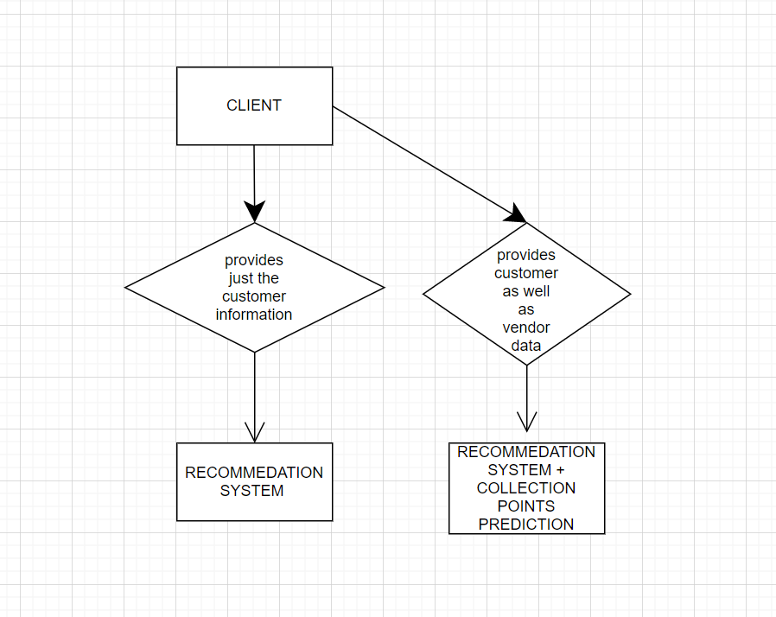

**Appendix B: Analysis Models**

|  |  |
| --- | --- |
|  |  |
|  |  |

|  |  |
| --- | --- |
|  |  |
| |  |  | | --- | --- | |  |  | |  |  |      |  |  | | --- | --- | |  |  | |  |  | |  |